abstract

In contemporary network security, Intrusion Detection Systems (IDS) are indispensable for safeguarding against a multitude of cyber threats. This paper presents an implementation framework focusing on four distinct machine learning algorithms—Support Vector Machines (SVM), Random Forest, Decision Tree, and Naive Bayes—for enhancing the efficacy of Intrusion Detection Systems. Each algorithm is meticulously tailored and integrated into the IDS architecture to address specific challenges posed by modern network environments. Through comprehensive experimentation and evaluation, the performance of each algorithm is assessed in terms of detection accuracy, false positive rates, and computational efficiency. Real-world datasets are utilized to validate the effectiveness of the proposed framework in identifying various types of intrusions while minimizing false alarms. Furthermore, considerations for scalability, adaptability, and deployment feasibility are discussed to facilitate seamless integration within diverse network infrastructures. This paper serves as a valuable reference for researchers, practitioners, and organizations seeking to deploy robust and versatile IDS solutions leveraging state-of-the-art machine learning techniques.

Keywords:

machine learning; deep learning; support vector machine; intrusion detection system; cyber security.

Introduction:

In today's digitally connected world, the protection of sensitive data and critical infrastructure against cyber threats has become increasingly challenging. Intrusion Detection Systems (IDS) stand at the forefront of defense, continuously monitoring network traffic to detect and mitigate unauthorized access and malicious activities. Traditional IDS solutions often struggle to keep pace with the evolving tactics of cyber attackers. However, the integration of advanced technologies such as Machine Learning (ML) and Deep Learning (DL) has revolutionized the landscape of intrusion detection.

Machine Learning and Deep Learning techniques offer the promise of enhanced accuracy and efficiency in identifying both known and unknown threats within vast streams of network data. Unlike traditional rule-based approaches, ML and DL empower IDS to adapt and learn from data patterns, enabling them to detect anomalies and suspicious behaviors that might evade conventional detection methods. Several algorithms, including Support Vector Machines (SVM), Decision Trees (DT), Naive Bayes (NB), and Random Forests (RF), have shown promise in this domain, each with its unique strengths in capturing complex patterns and distinguishing between normal and malicious activities.

This paper explores the synergy between Machine Learning, Deep Learning, and Intrusion Detection Systems, delving into the foundational concepts, methodologies, and real-world applications of SVM, DT, NB, and RF algorithms. We examine how these algorithms analyze network traffic, system logs, and other data sources to identify potential threats, and how they can improve the detection capabilities of IDS across various industries and organizational settings.

Furthermore, we discuss the challenges and opportunities associated with implementing these algorithms in intrusion detection, including data scarcity, model interpretability, and adversarial attacks. By understanding the strengths and limitations of SVM, DT, NB, and RF, organizations can make informed decisions in designing and deploying robust IDS solutions tailored to their specific cybersecurity needs.

Through this exploration, we aim to provide insights into the transformative potential of Machine Learning and Deep Learning, in conjunction with algorithms like SVM, DT, NB, and RF, in bolstering the effectiveness of Intrusion Detection Systems, ultimately enhancing the resilience of digital ecosystems against emerging cyber threats.

1. **Literature Survey**

**2.1. Paper Title: "Efficient Network Intrusion Detection and Classification System"**

**Authors:** Iftikhar Ahmad, Qazi Emad Ul Haq

**Abstract:** The proliferation of networked systems and the ever-evolving cyber threat landscape underscore the pressing need for robust intrusion detection and classification systems. This paper introduces an innovative approach to bolster the security of modern network environments. Our system utilizes advanced machine learning techniques and a streamlined architecture for real-time detection and classification of network intrusions. This real-time operation ensures prompt threat identification and response to mitigate potential damage and safeguard critical assets.

**2.2 Paper Title: "Network Traffic Analysis and Intrusion Detection with Packet Sniffer"**

**Authors:** Mohammed Abdul Qadeer, Mohammad Zahid

**Abstract:** In today's interconnected digital world, network security is paramount. Real-time network traffic monitoring and intrusion detection are pivotal for safeguarding assets and maintaining network integrity. This paper presents a novel approach that leverages a high-performance packet sniffer for efficient network packet capture and analysis. We employ advanced traffic analysis to identify normal patterns, perform protocol analysis, and detect deviations from established baselines. Our intrusion detection system classifies threats, such as denial of service (DoS) attacks, intrusion attempts, and malware propagation in real-time, enabling rapid incident response.

**2.3 Paper Title: "Multiclass Classification Baselines for Anomaly-based Network Intrusion Detection Systems"**

**Authors:** Ajay Shah, Sophine Clachar, Manfred Minimair, Davis Cook

**Abstract:** Network Intrusion Detection Systems (NIDS) are pivotal in safeguarding computer networks. Anomaly-based NIDS, which rely on identifying deviations from normal network behavior, effectively detect known and unknown threats. This paper addresses the challenge of developing comprehensive multiclass classification baselines for anomaly-based NIDS. We propose a systematic approach that utilizes diverse datasets and machine learning techniques. By evaluating various classifiers, including traditional algorithms and deep learning models, we provide insights into their suitability for NIDS.

**2.4 Paper Title:Comparing the Performance of Adaptive Boosted Classifiers in Anomaly based Intrusion Detection System for Networks**

**Abstract:**

The computer network is used by billions of people worldwide for variety of purposes. This has made the security increasingly important in networks. It is essential to use Intrusion Detection Systems (IDS) and devices whose main function is to detect anomalies in networks. Mostly all the intrusion detection approaches focuses on the issues of boosting techniques since results are inaccurate and results in lengthy detection process. The major pitfall in network based intrusion detection is the wide-ranging volume of data gathered from the network. In this paper, we put forward a hybrid anomaly based intrusion detection system which uses Classification and Boosting technique. The Paper is organized in such a way it compares the performance three different Classifiers along with boosting. Boosting process maximizes classification accuracy. Results of proposed scheme will analyzed over different datasets like Intrusion Detection Kaggle Dataset and NSL KDD. Out of vast analysis it is found Random tree provides best average Accuracy rate of around 99.98%, Detection rate of 98.79% and a minimum False Alarm rate.

# 2.5 Paper Title:Research of Intrusion Detection Method Based on IL-FSVM

**Abstract:**

Aiming at the problem that the traditional network intrusion detection algorithm has high learning time cost and low recognition accuracy for massive training data, the paper proposes an intrusion detection method based on incremental learning and FSVM(IL-FSVM). This method uses FSVM as the training and classification algorithm for intrusion detection, which reduces the impact of noise samples on intrusion detection and recognition. Based on FSVM, it introduces incremental learning to improve the learning efficiency of massive samples and reduce the learning time cost of the algorithm. The simulation results show that compared with the traditional SVM algorithm, the proposed algorithm can greatly reduce the training time and improve the learning efficiency of the intrusion detection algorithm on the premise of ensuring higher classification accuracy.

**Methodology:**

Firstly, the objectives and scope of the IDS are defined, including the types of threats it aims to detect and the network or systems it will monitor. Data collection follows, where relevant data sources such as network traffic logs and system logs are gathered. Subsequently, the collected data undergoes preprocessing to clean and prepare it for analysis, including tasks like noise removal and normalization. Feature selection or extraction is then performed to identify the most relevant characteristics for distinguishing between normal and malicious activities. Next, suitable machine learning and deep learning models are selected, trained, and evaluated using the preprocessed data. Model optimization may be conducted to fine-tune performance, and ensemble methods can be considered for enhanced detection capabilities. Once trained, the IDS is deployed in the production environment and monitored for performance. Regular maintenance and updates are essential to adapt to evolving threats and ensure continued effectiveness over time. Through this methodology, organizations can develop robust IDS solutions to protect against cyber threats effectively.

SVM:

Among the classification algorithms of support vector machines, kernel function method is the most advanced and effective one. Kernel function can effectively solve the problem of "dimension disaster" in traditional classification methods.

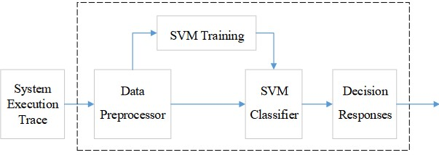

Figure 1.Structure of Intrusion Detection System based on SVM

m

1. Polynomial Function

K(x , x) = [(xi x)+1] q

1. Gaussian Kernel Function (Radial Basis Function, RBF)

Radial Basis Function (RBF) Kernel:

*K*(*xi*​,*xj*​)=exp(−*γ*∥ *xi*​−*xj* ​∥2)

1. Sigmoid Function

K(xi , x) = tanh[v(xi ⋅ x)+ c]

In the paper, the experiment adopted KDDCUP99 as the intrusion detection dataset. Each record in the data set corresponds to each TCP/IP connection. Each record is described by 41 characteristics (attributes). The original data set contains 22 attacks, it can be divided into four main types of attacks: DOS (denial of service attacks) and R2L (remote access of unauthorized), U2R (illegal access to the local super user) and Probing (scanning and detection). In the experiment, all types of attacks are classified as abnormal mode, and intrusion detection only needs to judge whether it is normal mode or abnormal mode. According to the observation of Data set of KDDCUP99, the data set is a set of heterogeneous data. The 41 features (attributes) of each record have both textual and numerical values, some of which vary widely, while others have only two values, 0 and 1. For such a heterogeneous problem, data normalization is needed.

DT:

decision trees serve as a powerful tool for identifying malicious activities within a network or system. These trees are constructed based on a dataset comprising various features extracted from network traffic or system logs. The fundamental principle behind decision trees in IDS is to recursively split the dataset into subsets, each containing instances with similar characteristics. This process continues until a certain stopping criterion is met, typically when all instances within a subset belong to the same class or when further splitting doesn't significantly improve classification accuracy.

The decision tree algorithm selects the best feature at each node to split the dataset. The selection criterion, often measured by metrics like information gain or Gini impurity, aims to maximize the homogeneity of instances within resulting subsets. Mathematically, information gain can be expressed as:

IG(D,A)=H(D)−H(D∣A)

where

IG(D,A) represents the information gain achieved by splitting dataset

D based on feature A.

H(D) denotes the entropy of dataset D, which measures its impurity or disorder.

H(D∣A) represents the conditional entropy of D given feature A, indicating the remaining uncertainty after considering feature A.

The decision tree continues to partition the dataset recursively until it reaches leaf nodes, which represent the final classification outcomes. In the context of intrusion detection, these outcomes typically correspond to benign or malicious activities.

Random forest:

Algorithm: Random forest modeling for network IDS

Input: NSL-KDD dataset

Output: Classification of different type of attacks

Step 1: Load the dataset

Step 2: Apply pre-processing technique Discretization

Step 3: Cluster the dataset into four datasets.

Step 4: Partition the data set into training and test

Step 5: Select the best set features using feature subset selection measure Symmetrical uncertainty (SU)

Symmetrical uncertainty compensates information gain

SU(X, Y ) = 2[I G(X/Y )/H(X)H(Y )]

Step 6: Data set is given to Random forest for training

Step 7: The test data set is then fed to random forest for classification

Step 8: Calculate accuracy, Detection rate, False alarm rate, Mathew correlation coefficient

For our experimental analysis, we downloaded the NSL-KDD dataset in ARFF format. We adopted the following

preprocessing techniques to run the experiment.

1) Replace missing values:

we used replace missing values filter to replace all missing feature values in NSL-KDD dataset.

This filter replaces all missing values with the mean and mode from the training data.

2) Discretization:

Numeric attributes were discretized by discretization filter using unsupervised 10 bin discretization.

Naïve Bayes:

The naïve Bayes model is a simplified Bayesian probability model that calculates the probability of an end result given several related evidence variables. It assumes independence among these variables, meaning that the probability of one attribute occurring does not affect the probability of another. In intrusion detection, this model can be applied to scenarios like alarm monitoring for theft detection, where attributes such as weather conditions or seismic activity serve as evidence variables.

Mathematical Equation: P(C∣F1, F2,…, Fn) = P(C).P(F1|C).P(F2|C)…..P(Fn|C)

P(F1)⋅P(F2)⋅...⋅P(Fn)

In this framework, the probability of theft occurrence is the class variable of interest, while other attributes provide evidence regarding theft likelihood. The model operates on the assumption of strong independence, making 2^n! independent assumptions given n attributes. Despite this simplification, naïve Bayes classifiers often yield accurate results.

Research has examined factors influencing classifier performance, identifying three main sources of error: training data noise, bias, and variance. Noise in training data can only be minimized by selecting high-quality training samples. Bias arises from overly large groupings in the data, while variance results from overly small groupings. Balancing these factors is crucial for optimizing classifier accuracy and mitigating errors in intrusion detection scenarios.

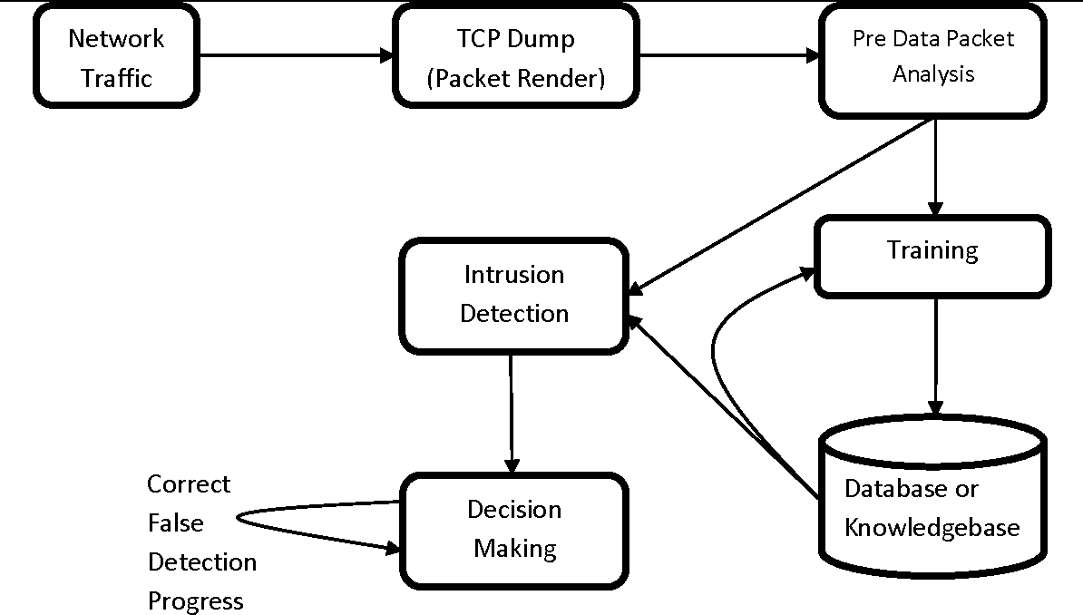

Fig 2:System Architecture Of IDS

Result

|  |  |  |
| --- | --- | --- |
| Serial No. | Classification algorithm | Accuracy Obtained |
| 1 | SVM | 76.410 |
| 2 | RF | 92.820 |
| 3 | DT | 92.820 |
| 4 | NB | 41.538 |

Table 1: Accuracy comparison table

**CONCLUSION**

Cybercriminals target computer users by using cutting-edge techniques and social networking strategies. Some hackers are more skilled and driven than others. Cybercriminals have demonstrated their ability to conceal their identities, their communications, and their illicit earnings, as well as their use of robust infrastructure. Therefore, it becomes more and more important to protect computers with cutting-edge IDSs capable of detecting contemporary malware. For creating or creating such IDS systems, it is crucial to have a thorough understanding of the advantages and disadvantages of contemporary IDS study. We also provided a thorough analysis of the methods, varieties, or technologies for intrusion detection systems, along with their advantages and disadvantage

**REFERENCES**

1. William Stallings, “Cryptography and Network Security”, 5th edition, Pearson Education.
2. Simon Hansman. “A Taxonomy of Network and Computer Attack Methodologies” 2003, url: https://www.cosc.canterbury.ac.nz/research/reports/HonsReps/2003/hon s_030.pdf (visited on 11/09/2019).
3. Abhishek Pharate , Harsha Bhat , Vaibhav Shilimkar “Classification of Intrusion Detection System” IJCS Volume 118 – No. 7, May 2015.
4. 4. SNORT. (2017). Snort 2.9.7.6. [Online]. Available: <https://www.snort.org/>
5. OISF. (2018). Suricata 4.0.4. [Online]. Available: <https://suricataids.org/about/>
6. T. Sree Kala, Dr .A. Christy “A Survey and Analysis of Machine Learning Algorithms for Intrusion Detection System” Jour of Adv Research in Dynamical & Control Systems, 04-Special Issue, June 2017.
7. <https://www.guru99.com/machine-learning-tutorial.html>.
8. Thuy T.T. Nguyen and Grenville Armitage “A Survey of Techniques for Internet Traffic Classification using Machine Learning” IEEE COMMUNICATIONS SURVEYS & TUTORIALS, VOL. 10, NO. 4, FOURTH QUARTER 2008.
9. Shilpa Bahl and Dr. Deepak Dahiya “Features Contribution for Detecting Attacks of an Intrusion Detection System” Global Journal of Pure and Applied Mathematics. ISSN 0973-1768 Volume 13, Number 9 (2017), pp. 5635-5653.
10. https://www.analyticsvidhya.com/blog/2016/12/introduction-to-feat ure-selection-methods-with-an-example-or-how-to-select-the-right-vari ables/

Sumaiya Thaseen Ikram , Aswani Kumar Cherukuri “Intrusion detection model using fusion of chi-square feature selection and multi class SVM” Computer and Information Sciences (2017) 29, 462–472.